Born in Wyndham in 1944, Norman Horace was educated at Forrest River Mission. As a teenager Norman learned the art of boxing at the Wyndham meatworks youth club operated by Kevin Hannah. In about 1962 in Darwin he joined up with Bells Boxing Troupe”, where he “enjoyed travelling around and meeting new people”. He told Neville Green, “It gave me a good education and a chance to learn about life.”
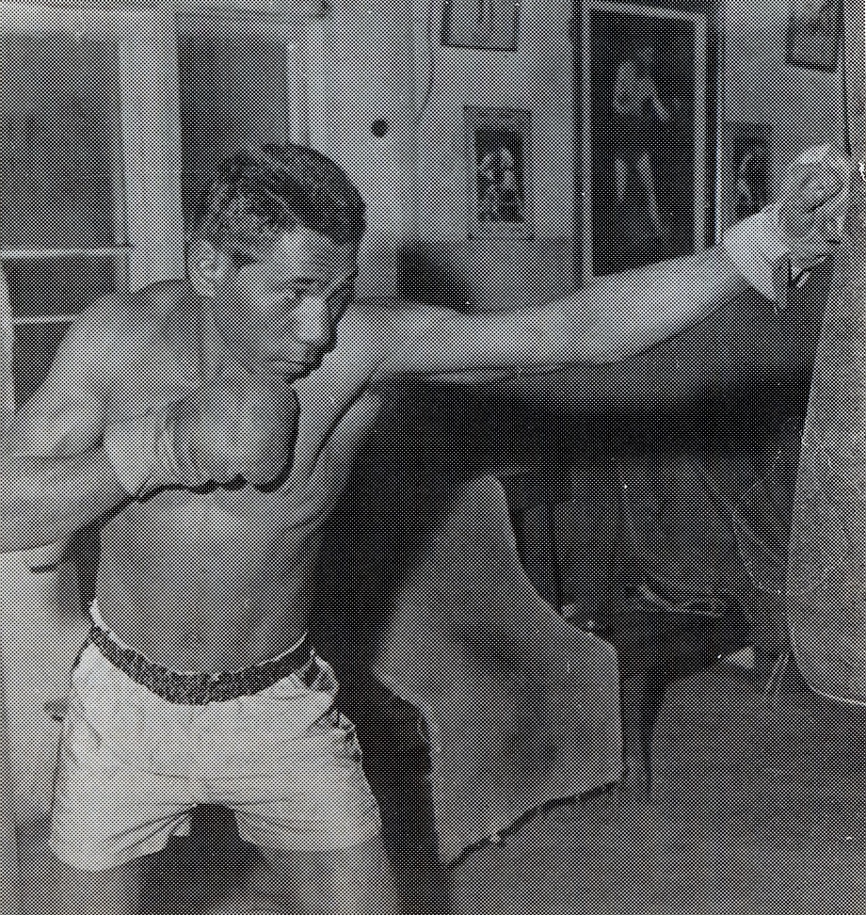
At the age of 19, on April 6, 1964, as “Kid Langford”, he stepped into the boxing ring at the Sydney Stadium in his debut profession fight. It was the beginning of a career lasting six and a half years. After winning the Australian Super Light Title, a highlight of Norman’s career was an eight-month boxing contract in Japan.

